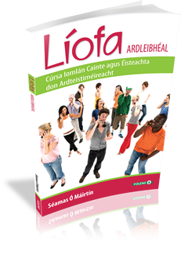

(Picture taken from folens.ie)
The book I am selling is like new CDs for the Sraith picture are not included

